Corbin Charpentier

Lab 5

**Classifier used**

DecisionStump

**Test Options used**

Percentage split 66%

**Confusion Matrix in the form of a table**

=== Confusion Matrix ===

a b c <-- classified as

15 0 0 | a = Iris-setosa

0 0 19 | b = Iris-versicolor

0 0 17 | c = Iris-virginica

**Figure of the ROC curve**

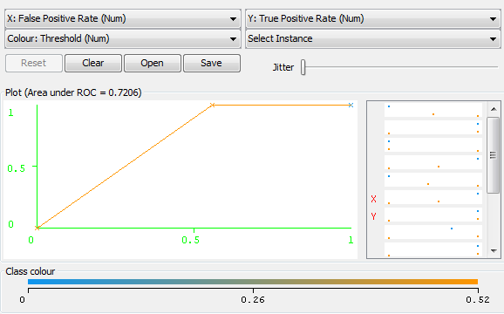

**The top 2 ranked attributes when you choose the Attribute Evaluator as ‘ChiSquaredAttributeEval’ and Search Method as ‘Ranker’.**

268.419 3 petallength

266.908 4 petalwidth

**P, R and A measures**

TP Rate FP Rate Precision Recall F-Measure ROC Area Class

1 0 1 1 1 1 Iris-setosa

0 0 0 0 0 0.734 Iris-versicolor

1 0.559 0.472 1 0.642 0.721 Iris-virginica

Avg 0.627 0.186 0.452 0.627 0.508 0.808